Survival Analysis of Customer Churn: Risk Factors and Retention Modeling in the Telecommunications Industry
Team Members: Arezki BALI
Introduction Customer retention is a critical metric for subscription-based businesses, where "churn" (the loss of a customer) directly impacts revenue. Traditional predictive models often treat churn as a simple binary classification problem. However, this approach ignores the "time-to-event" aspect of customer behavior—specifically, when a customer is likely to leave. This report applies survival analysis techniques to the Kaggle Telco Customer Churn dataset to estimate retention curves, compare customer subgroups, and identify significant hazard factors associated with churn.
Methods
Data Processing The analysis utilized a dataset of 7,043 customers, containing demographics, service details, and billing information. The primary outcome variable, Churn, was converted to a binary indicator (1 = Churn, 0 = No Churn). The time-to-event variable was defined as tenure in months.
During data cleaning, the TotalCharges variable was converted to numeric. A logical inconsistency was identified where customers with zero tenure had missing values for total charges; these were imputed to 0 to retain them in the analysis. Categorical predictors, including contract type, payment method, and internet service, were converted to factors for modeling.
Statistical Analysis The analysis followed a two-stage approach. First, non-parametric Kaplan-Meier (KM) estimators were used to visualize survival curves for the overall population and stratified by contract type. Differences between groups were assessed using the log-rank test.
Second, a semi-parametric Cox Proportional Hazards model was built to estimate the hazard ratios of various predictors. A full model including MonthlyCharges, Contract, InternetService, PaymentMethod, PaperlessBilling, gender, and Partner was initially specified. Stepwise selection based on the Akaike Information Criterion (AIC) was employed to refine the model and select the most predictive features.
Model performance was validated using a 50/50 train-test split. Discrimination was assessed using the Concordance Index (C-statistic) on the test set and Time-Dependent ROC curves at 12, 24, and 36-month horizons using the Nearest Neighbor Estimation (NNE) method. Finally, the proportional hazards assumption was checked using scaled Schoenfeld residuals and visual inspection of time-varying coefficients.

Results
Survival Probabilities The Kaplan-Meier analysis revealed significant differences in retention based on contract type. The log-rank test returned a p-value of < 0.0001, confirming that survival curves for "Month-to-month", "One year", and "Two year" contracts are statistically distinct. As visualized in Figure 1, month-to-month customers experience a sharp decline in retention during the first 20 months, whereas customers on two-year contracts maintain a retention probability near 100% for the duration of the study period.
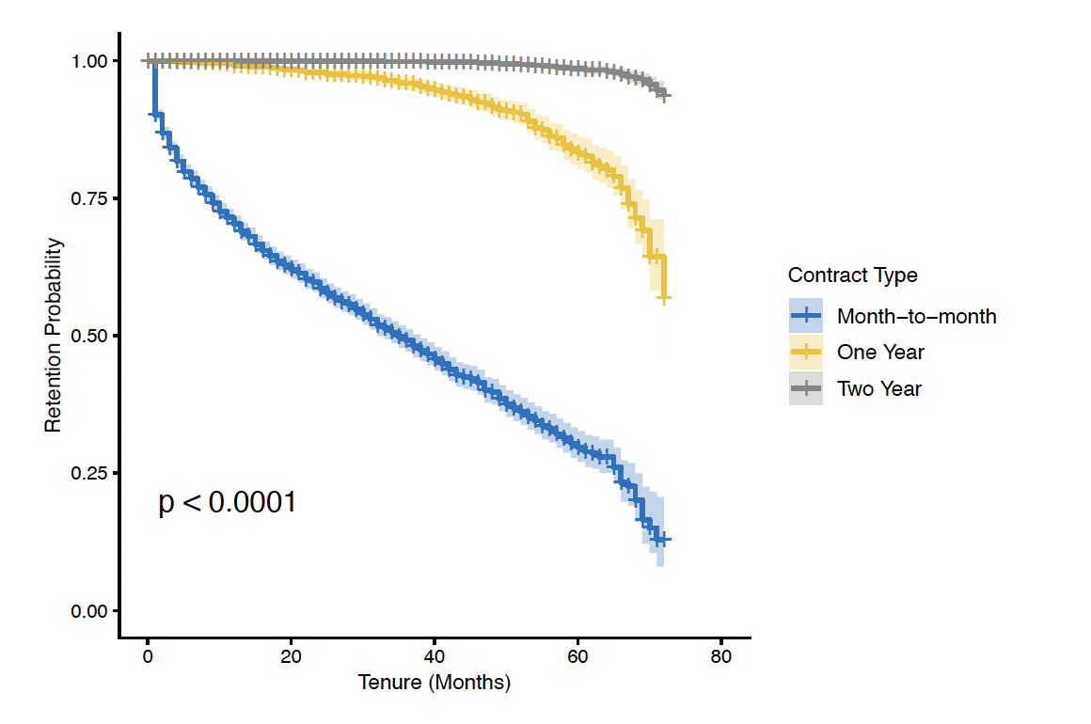
Figure 1: Kaplan-Meier survival curves stratified by Contract Type. Shaded areas represent confidence intervals. The steep drop in the blue line indicates high early churn for month-to-month customers.
Multivariable Cox Regression The final Cox model identified Contract, InternetService, PaymentMethod, PaperlessBilling, and MonthlyCharges as highly significant predictors of churn (p < 0.001).
The forest plot of hazard ratios (Figure 2) indicates that contract type is the strongest protective factor. Compared to month-to-month customers, those with one-year contracts have an ~82% lower hazard of churn (HR ≈ 0.18), and those with two-year contracts have a ~97% lower hazard (HR ≈ 0.033). Conversely, customers with Fiber Optic internet service showed a dramatically increased risk, with a hazard ratio of 4.34 compared to DSL users. Payment method also played a role; customers paying via "Electronic check" had nearly double the hazard (HR ≈ 1.95) compared to those using automatic bank transfers.
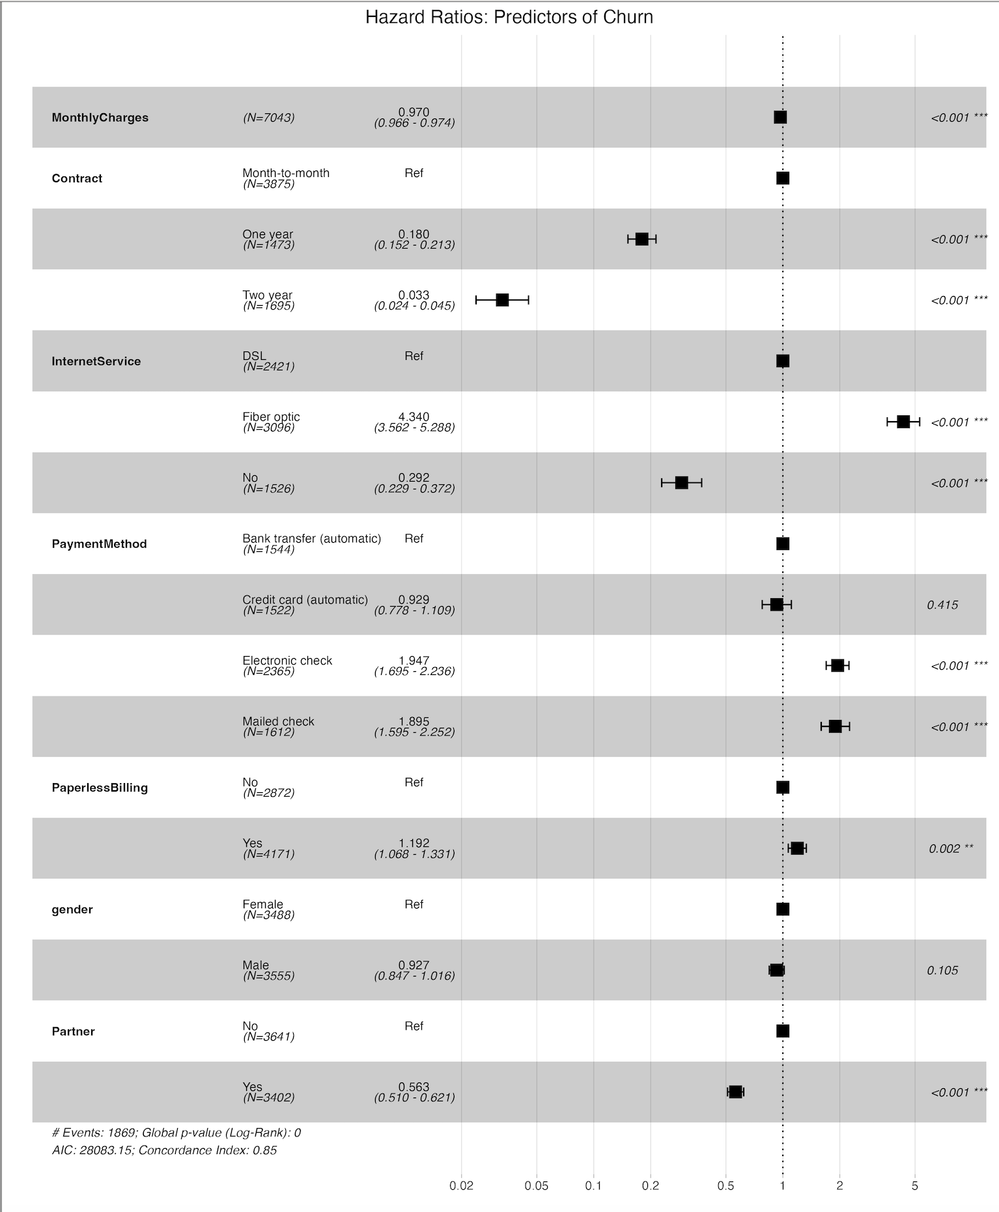
Figure 2: Forest plot displaying Hazard Ratios (HR) for the final Cox model. HRs > 1 indicate increased risk of churn, while HRs < 1 indicate protective factors.
Model Validation and Diagnostics The model demonstrated strong predictive power on the unseen test data, achieving a C-statistic of 0.847. Time-dependent ROC analysis (Figure 3) showed consistent discrimination over time, with AUC values of 0.860 at 12 months, 0.869 at 24 months, and 0.879 at 36 months.
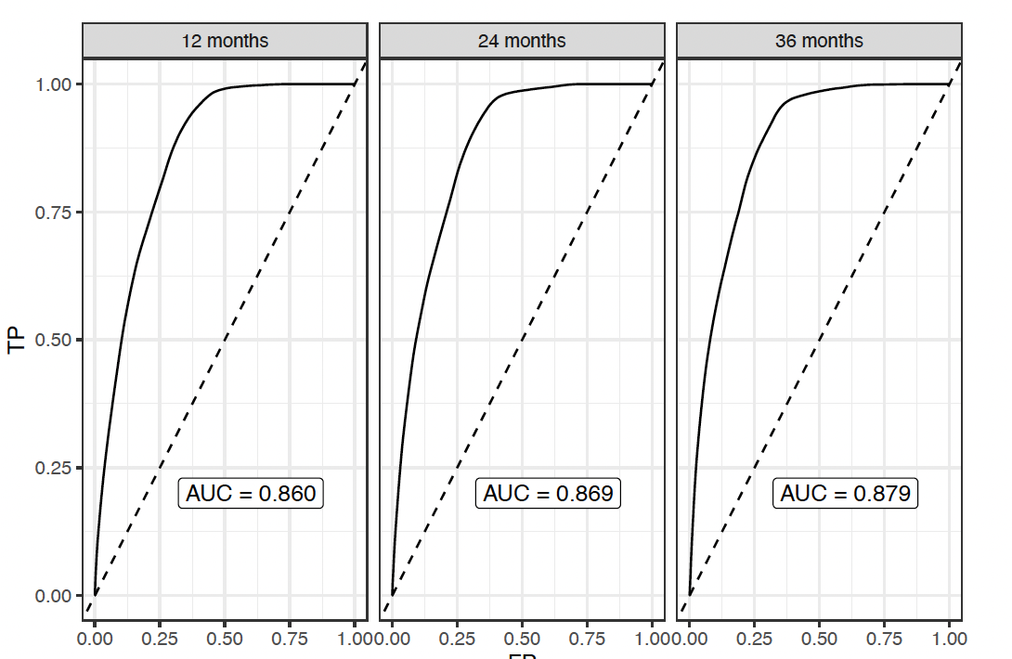
Figure 3: Time-dependent ROC curves evaluated at 12, 24, and 36 months on the test set. The AUC increases slightly over time, indicating robust long-term discrimination.
However, diagnostic tests revealed violations of the proportional hazards assumption. The global Schoenfeld test was significant (p < 2e-16), with specific violations found in the Contract, MonthlyCharges, and InternetService variables. The plot of Beta(t) for Contract (Figure 4) confirms that the protective effect of long-term contracts diminishes slightly over time but remains directionally consistent.
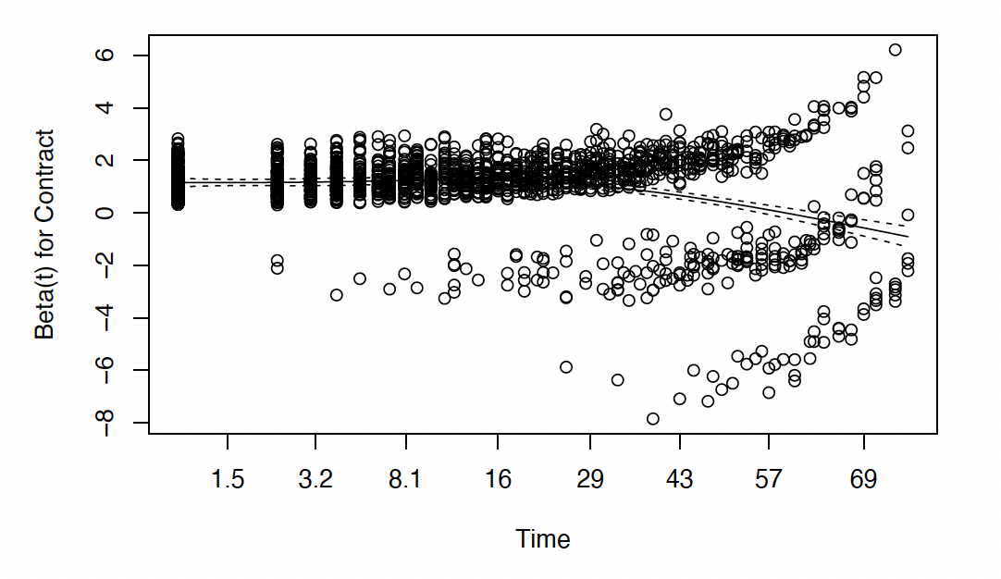
Figure 4: Schoenfeld residuals for the Contract variable. The slope suggests the coefficient changes over time, indicating a violation of the Proportional Hazards assumption.
Interpretation of Findings The analysis confirms that contract length is the single most dominant driver of customer retention. The hazard ratios indicate that moving a customer from a month-to-month plan to a two-year contract reduces their churn risk by approximately 97%. However, a critical area of concern is Fiber Optic service. Despite likely being a premium product, it is associated with a 4-fold increase in churn risk (HR = 4.34) compared to DSL. This suggests a potential misalignment between price and service quality, or aggressive competitor pricing in the fiber market.
Business Recommendations Based on these statistical results, the following strategies are recommended to reduce churn:
- Incentivize Long-Term Contracts: Since the "lock-in" effect is the strongest predictor of retention, marketing efforts should focus on migrating month-to-month users to 1-year or 2-year contracts, perhaps by offering the first month free or a rate lock.
- Investigate Fiber Optic Dissatisfaction: The abnormally high churn rate among Fiber Optic customers is a red flag. The business should immediately conduct satisfaction surveys or price-benchmarking for this segment to identify if the issue is service outages or cost sensitivity.
- Promote Automatic Payments: Customers paying via "Electronic check" are nearly twice as likely to churn as those on automatic bank transfers. Incentivizing users to switch to "Credit Card (Automatic)" or "Bank Transfer (Automatic)"—potentially through a small "Auto-Pay Discount"—could structurally lower churn risk.
- Early Tenure Intervention: The survival curves show the steepest drop in the first 12 months. Retention resources (such as onboarding calls or "check-in" offers) should be heavily front-loaded to the first year of a customer's tenure, rather than spread evenly over time.
Conclusion The survival model demonstrates high predictive accuracy (C-statistic: 0.847), making it a reliable tool for identifying at-risk customers. By addressing the specific risk factors identified—particularly contract type and internet service satisfaction—the business can proactively intervene to improve overall customer value.

